**K9HZ 20W 1-54 MHZ PA**

**BUILD INSTRUCTIONS for PCB V2.4**

**June 5, 2024**

**Operating Data**

Power Requirements: 12-15 VDC at 3A max.

Frequency Range: 1.8MHz – 54Mhz.

Input: 1mw nominal, 50 ohms. Pad provided for higher power input.

Output: 10Wor 15W RMS minimum, 20W PEP (see text below), 50 ohms.

Pre-driver: OPA2674ID High Frequency Dual Video Amplifier.

Final Transistor Complement: Push-Pull pair of RD16HHF1-501.

Class of Operation: Normally AB2, but can be any class C-A.

Bias Setting: 250ma per RD16HHF1 for AB2 operation.

PTT: 3-12V positive voltage at J3.

Modes of Operation: AM, CW, SSB, FM.

**Inventory and Prework**

Before you begin, inventory your parts against the latest BOM to make sure you have everything you need to complete the PA build. The complete BOM is given in Table 1.

Before you start soldering parts onto the PCB, you should also either transcribe the mounting holes for the board onto the heatsink, or make a template of the hole locations from the circuit board on a piece of paper for later use.

Start by examining the board to understand the parts layout in conjunction with the schematic (see Figures 1 and 2). There are a few things you need to decide:

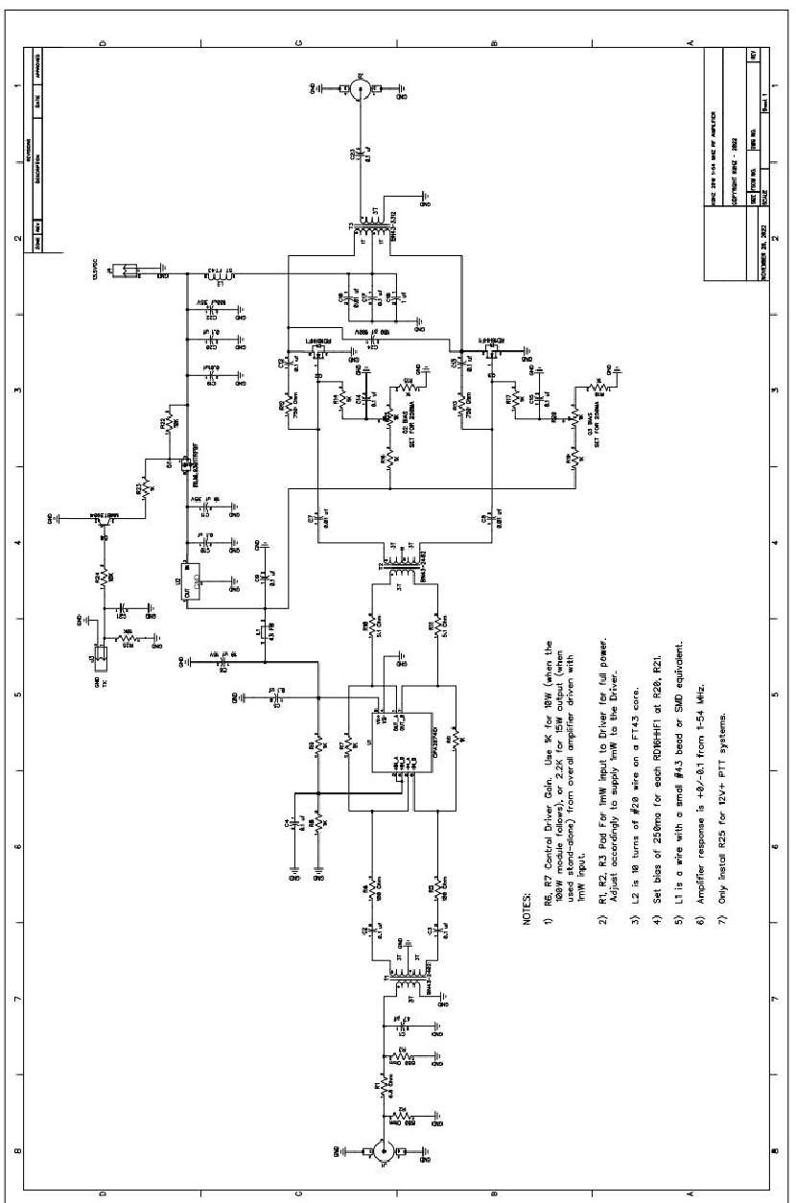

*Figure 1. PA schematic.*

*Figure 2. PCB layout.*

1. Will you be using this PA alone or will you be driving the matching 100W module?
   1. **20W PA Stand-alone**: use 2.2K resistors for R6 and R7.
   2. **20W PA with 100W Module**: use 1.0K resistors for R6 and R7.

The 2.2K feedback resistors provide up to 15W RMS output. The 1K resistors at these positions will keep the amp to 10W RMS, which is the maximum power the 100W module can tolerate without inserting a power divider pad.

1. Note that the power input of the PA is 1mw RMS and 5mw PEP. Higher input power levels can be accommodated by adjusting R1, R2, and R3 on the input power PAD. Use an appropriate Pi-type Pad calculator to determine R1, R2, and R2 for higher powers as shown in Figure 3.

*Figure 3. Power Divider PAD: PI Attenuator.*

**Building the PA**

With a medium heat soldering iron (30-40W), begin the assembly of the PA board in this order:

1. Place semiconductors except for the RD16HHF1s (Q2, Q3) onto the board first. Note the U1 symbol on the PCB is at the top of the part (pin 1 left, pin 8 right, See Figure 4).

*Figure 4. Location of PIN-1 For OPA2674 Part Placement On The PCB*

1. Place all chip capacitors and resistors on the board. Use the schematic placement if there are any issues reading the part legends on the PCB. NOTE that C23 is mis-marked on V2.3 and earlier PCBs as C24 (see Figure 5).

*Figure 5. C24 Mislabeled. This Is Actually C23.*

Also, actual disc capacitor(s) C24 go(es) across T3 primary terminals at the transformer and should be the last component soldered onto the board (e.g. after T3 is soldered to the board). A discussion of the value for C24 is below. C25 (0.1uF) is a board REV 2.4 addition for better RF impedance.

1. Place all of chip resistors on the board. Only use R25 if the PTT circuit is above 5V (e.g. Is 12V). Otherwise, leave this component position open.
2. Install L1 on the board; L1 is formed from placing the FT43-101 bead onto a lead cut off from a ¼ or ½ watt leaded resistor. The spot is not marked so use the photo below for placement. See Figure 6 for the proper location.

*Figure 6. Placement Of L1 – FT43-101 Bead.*

1. Place the one electrolytic capacitor C22 on the board.
2. Place the two bias pots R20 and R21 (mismarked as R26 & R27 on earlier boards).
3. Wind the three transformers (T1, T2, and T3) and the choke (L2):

* 1. Winding T1:
     1. T1 is 3 turns of #30 wire on a BN43-2402 for the primary, and 6 turns center tapped (so 3T+3T) on the secondary.
     2. You are provided with 36” of #30 transformer wire that has a 155C breakdown temperature for easy stripping and soldering. This wire is used for winding both T1 and T2.
     3. For T1, begin by cutting the following lengths of wire from that provided:

1. Cut three pieces of wire 4” long. One will be used for winding the Primary (3T) of T1 and two will be used for winding the secondary (3T each side of the center tap).

* 1. Strip 3/8” of the insulation from one end each of two wires. Do this by placing a blob of solder on the end of your soldering iron and using it to tin 3/8” of the end of both wires. See Figure 7.

*Figure 7. Using Solder to Strip Magnet Wire.*

* 1. Twist the tinned ends together, solder them, and place the legs through the sides of one of the BN43-2403 cores (see Figure 8).

*Figure 8. Soldered Legs Forming CT Inserted In B43-2403 Core.*

* 1. Wind two more turns using one leg, and two more turns using the other leg for a total of SIX turns (center tapped at 3 turns each) The secondary should now look like you see in Figure 9.

*Figure 9. Completed T1 Secondary – 3T + 3T.*

* 1. Now take the remaining 4” piece of wire (cut above) and wind the primary. Start with about 1 inch of wire sticking out of the OPPOSITE side of the core from the primary. Make sure you have 3 passes through BOTH sides of the core for the primary. The completely wound transformer should look like Figure 10.

*Figure 10. T1 Transformer Windings Completed.*

* 1. Use the same wire-stripping technique used in step “iv” above to complete stripping and tinning all leads on the transformer. Trim the leads to fit the space allotted for T1 on the circuit board. See Figure 11.

*Figure 11. Trimmed T1 Transformer Leads Ready For PCB Soldering.*

* 1. Before installing, Test to see that there is no continuity between the primary and the secondary with an ohm meter.
  2. Solder the transformer into place paying attention to the center tap on the SECONDARY side of the transformer (see figure 12).

*Figure 12. T1 In Place On The PCB.*

1. Winding T2:
   * 1. Like T1, T2 is 3 turns of #30 wire on a BN43-2402 for the primary, and 6 turns on the secondary. The difference is that T2 DOES NOT have a center-tapped secondary, whereas T1 does.
     2. For T1, begin by cutting the following lengths of wire from that provided:
        1. Cut one piece of #30 transformer wire 4” long. This will be used for winding the Primary (3T) of T2.
        2. Cut one piece of #30 transformer wire 6” long. This will be used for winding the secondary (6T) of T2.
     3. Start with the 4” piece of wire. Leave about a 1” lead and wind three turns (3T) on the core. This is the primary of the transformer. See Figure 13.

*Figure 13. T2 Transformer Primary – 3T of #30 Magnet Wire*

* + 1. On the other side of the core, leave about a 1” lead and wind six turns (6T) This is the secondary of the transformer. Clearly mark the primary and the secondary. See Figure 14.

*Figure 14. T2 Transformer Secondary Completed – 6T of #30 Magnet Wire.*

* + 1. Use the wire-stripping technique in building T1 above to complete stripping and tinning all four leads on the transformer. Trim the leads to fit the space allotted for T1 on the circuit board. See Figure 15.

*Figure 15. T2 Transformer Ready For Mounting On The PCB.*

* + 1. Before installing, Test to see that there is no continuity between the primary and the secondary with an ohm meter.
    2. Solder the transformer into place paying attention to the PRIMARY and the SECONDARY sides of the transformer (see Figure 16).

*Figure 16. T2 Transformer Soldered In Place On The PCB.*

1. Winding T3:
   * 1. T3 is 2 Turns of #20 silver-coated/ stranded TFE wire center tapped on the primary (1T+1T), and 3 turns on the secondary of a BN43-3312 core.
     2. You are provided 24” of #20 silver coated copper stranded TFE wire.

Cut the wire into 4 pieces of length as given:

* + - 1. One piece that is 6” long. This is for L2.
      2. Two pieces that are 3 ½” Long. These are for the T3 Primary.
      3. What remains in a piece 11” long. This is for the T3 Secondary.
    1. Set the 6” long piece aside for winding L2 in the next section.
    2. Strip 3/8” of insulation from one end of each of the two pieces of wire that are 3 ½” long.
    3. Twist and solder the stripped ends together and solder them as shown in Figure 17.

*Figure 17. Two Wires Soldered Together To Form The T3 Primary Center Tap.*

* + 1. Place the legs of the wires soldered together through opposite sides of the core as shown in Figure 18.

*Figure 18. Legs Placed Into The BN43-3312 Core.*

* + 1. Wind an additional half-turn on each leg through the core to complete the 1T+1T primary (see Figure 19).

*Figure 19. Completed T3 Primary – 1T + 1T.*

* + 1. Wind the secondary on the opposite side from the primary. Start with one inch of wire protruding from the core on one side, wind three turns through both sides of the core as shown in figure 20.

*Figure 20. Completed T3 Secondary – 3T.*

* + 1. Cut the wires back so that only about 3/8” wire protrudes from the core at each wire end. Strip each of the wires back ¼” as shown in Figure 21.

*Figure 21. T3 Dressed And Ready To Mount On The PCB.*

* + 1. Solder T3 down to the PCB. You can get it tight to the board by soldering down the primary and they using forceps or a small needle nose plyers to hold the secondary leads in place for soldering. The finished product should look like Figure 22.

*Figure 22. T3 Transformer Soldered In Place On The PCB.*

1. Winding L2:

i. L2 is 7 turns of #20 silver-coated/ stranded TFE wire on a FT50-43 core.

(If you want to use the PA down in the 1-3.5 MHz region, use 10 turns). ii. Strip ¼” of insulation from one end of the wire. Start winding from that end of the wire leaving about ¼” of insulated wire and the additional ¼” of stripped wire at the starting end.

* + 1. Wind 7 turns (7 paths thru the center of the core).
    2. You can glue the ends of the wire in place on the core with hot glue if you prefer.
    3. At the finish of the 7 turns, leave ½” of wire, and strip that back ¼”. See Figure 23.

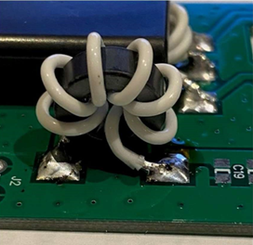

*Figure 23. Finished L2 Choke Mounted On The PCB.*

* + 1. Solder one end of L2 to one of the pads for L2 on the circuit board.
    2. With a forceps or small needle nose plyers, hold the other end of L2 on the remaining solder pad and solder the wire.

* 1. Finally, Place J1, J2, J3, J4 connectors. Lift the SMA connectors above the board just slightly prior to soldering so that it does not short the center conductor to the connector shell (see Figure 24).

*Figure 24. Mounting The SMA Connector.*

* 1. Test the board at this point. With a high impedance ohm meter, you should measure several megohms at the power terminal.

**Final Steps**

* 1. Drill and tap your heatsink to match the mounting holes on the corners of the board.
  2. Place two or three small flat washers under the each of the four corners of the board such that none of the thru-hole parts (PTT connector, power connector, SMA connectors, and bias pots) touch the heat sink. Use a sheet of paper to test that there is clearance.
  3. Use the board and RD16HHF1s to find the best places for holes on the heatsink. Drill and tap.
  4. Use 1/8” plastic spacers under the corners of the board so it does not short out of the heat sink.
  5. Use some heat transfer goop on the RD16HHF1s and screw them down to the head sink. A little goop goes a long way. Solder the leads in place.
  6. MARK “+” and “-“ ON THE POWER CONNECTOR with a marker. The “+” side is the furthest from the output SMA connector.
  7. Connect a 50 ohm resistor across the input connector, and the output to a dummy load via a watt meter, 12-14VDC to the power connection (WATCH THE POLARITY!) through an ampmeter capable of at least 4 amps, PTT (positive polarity) to J3. DO NOT POWER UP YET.
  8. Adjust R20 to and R21 to fully CLOCKWISE (CW) position. Check the wiper resistance to ground to make sure its 1K ohms. This indicates the lowest bias point.
  9. Power up the amp. The RD16HHF1s should remain cool.
  10. Switch on the PTT (J3:1) on (3V is all that is needed). You should see less than 50 milliamps on the amp meter. Adjust slowly R20 CCW to increase the current draw by 250 milliamps. Then adjust R21 CCW to increase the current draw by an additional 250 milliamps. Release PTT.
  11. Connect the input to a source of 1mw or less, switch on the PTT (J3). Check the output. Depending how you selected R6 and R7 in Step #1, you should see a minimum of either 10W or 15W output no matter what frequency you are on between 1-54MHz.
  12. The amp is now ready for service!

**Other Considerations and Performance Enhancements**

* 1. There is some variation in the mixes of the transformer cores, and that can cause slight variations in the frequency response of the PA. What you may see is less gain at 54Mhz than at 1.8Mhz. C24 (Figure 25) is specifically used to correct this situation and flatten

*Figure 25. C24 At The Primary Of T3.*

* 1. the gain curve with frequency The best way to select C24 is with a spectrum analyzer or watt meter, plotting the output of the amplifier with frequency for a fixed input of 1mw over that same frequency range.
  2. What has been observed is that a value of C24 between 50pf and 350pf can be used to successfully shape the gain curve. Lower values of C24 tend to make the PA generate more gain in the 54Mhz range, whereas values in the 250-350pf range cause more gain in the 21-35Mhz range. If you plan on using the PA only in the 1.8-30 MHz range, use a value of 150pf-350Pf for C4. If you plan to use the PA in the 3.5-50 Mhz, then use values for C24 in the 0-100pf range, the exact value that gives you the flattest gain with frequency as is shown by your specific data for your PA.
  3. Note that some gain shaping can also be done by placing small value capacitors across the PRIMARY of T2. This should be done by experimentation.
  4. Note that V2.4 boards have a space for an additional C25 capacitor (not listed on the BOM) right at the center-tap of the T3 primary to ground for better RF control. It has been reported that a 0.1uF chip cap here can improve the RF suppression on the DC line and better power out above 30 MHz. You can experiment with this a bit.

Table 1. The Latest BOM for V2.4

